Chapter 5, Problem 7.

The op amp in Fig. 5.46 has R_{i} = 100 kΩ, R_{o} = 100 Ω, A = 100,000. Find the differential voltage v_{d} and the output voltage v_{o}.

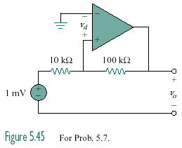
+
–

Figure 5.46
For Prob. 5.7.

